German Manual: Language and Culture

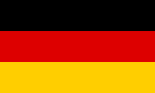

Prepared by
Celeste Chamberlain, BS
Laura Collier, BS
Bonnie Boudreau, BS
Nikki Bott, BA

Texas State University class of 2010

Academic Advisor
Rahul Chakraborty

Table of Contents
Demographics and Language 5
Demographic Information 6
Languages Spoken in Germany 6
Linguistic Community 6
Geographical Distribution 7
Demographics of Germany 8
Population in the US 9
Phonology 10
German Vowels 10
German Consonants 11
Syllable Stress 12
Syntax 12
Declaratives 12
Questions 13
Negation 13
Time, Manner, Place 13
Morphology 13
Nouns 13
Pronouns 13
Plural Forms 14
Verbs 14
Prepositions 14
Gender 14
26 Common English Pronunciation Errors made by German Speakers 15
Common Errors made in English by German Speakers 16
Tests & Assessment Materials 17
Pragmatics 17
History of Germany 19
World War II 19
Culture of Germany 20
Society and Culture 20
Food and Drinks 21
Speech-Language Pathologists and Audiologists 22
Web Resources 23
German Cuisine 23
German Language 23
German History 23
German Traditions 23
Therapy Materials 24
Research Articles 24
Case History For Bilingual Speakers 27
References 29

Demographics and Language
German is the official language of Germany. It is the 10th most widely spoken language in the world with approximately 98 million people speaking German.
The above information is from: http://www.photius.com/rankings/languages2.html
Germany is located in Central Europe and shares borders with Austria, Belgium, Czech Republic, Denmark, France, Luxembourg, Netherlands, Poland, and Switzerland.
The capital of Germany is Berlin. The German government’s political structure is a federal republic.
The above information is from: http://www.kwintessential.co.uk/resources/global-etiquette/germany-country-profile.html
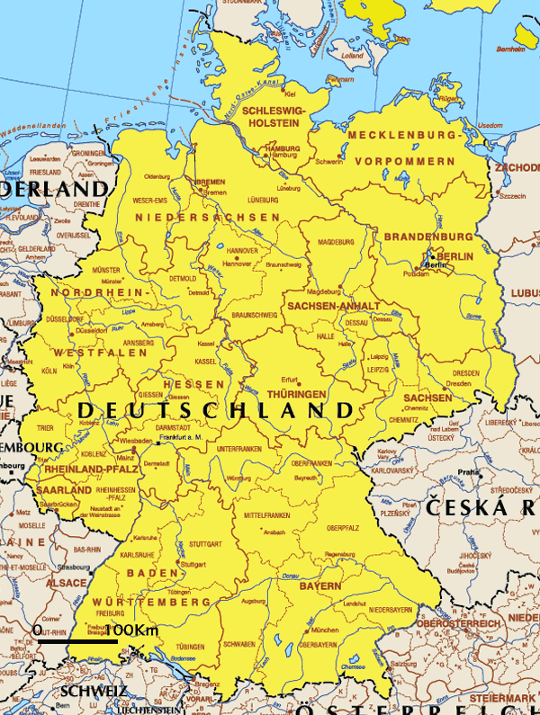
The above map from: http://europa.eu/index_en.htm

Demographic Information
The German population (as of July 2004) was estimated to be 82,424,609. Of these, 91.5% were German, 2.4% were Turkish, and the remaining 6.1% were largely Greek, Italian, Polish,
Russian, Serbo-Croatian, and Spanish.
The most practiced religions are Protestant 34%, Roman Catholic 34%, Muslim 3.7%, unaffiliated or other 28.3%.
The above information from: http://www.kwintessential.co.uk/resources/global-etiquette/germany-country-profile.html.

Languages Spoken in Germany
The official language of Germany is German and more than 95% of the people speak German as their native language. Other languages spoken in Germany are Sorbian, spoken by 0.09% in the east of Germany; North and West Frisian, spoken around the Rhine estuary by around 10,000 people, or 0.01%, who also speak German. Sample of spoken German
http://europa.eu/abc/european_countries/languages/german/index_en.htm?_de
Danish is spoken by 0.06%of the population, mainly in the area along the Danish border. Romani, an indigenous language is spoken by around 0.08%.
Immigrant languages include Turkish, which is spoken by around 1.8%, and Kurdish, by 0.3%.

Linguistic Community
German has traditionally been divided into three major dialects which have major linguistic and social divisions. Low German is spoken in the north. Central and Upper German (High German) are spoken in the south of Düsseldorf. These two dialect areas are characterized by different linguistic value systems, regional non-standard varieties of German have more of a stigma in the north than in the south.

The above information is from German Culture and Society (Briel, H., 2002)
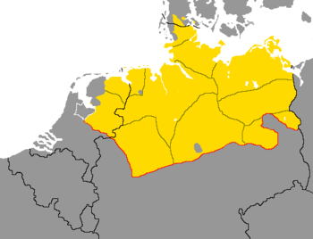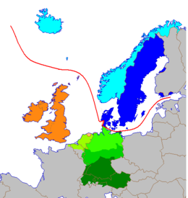
Low German dialectal area. High German dialectal area: central and south of Germany (darkest shades of green).
Above images are from http://en.wikipedia.org/wiki/High_German.

Geographical Distribution
German is an official language in Austria, Belgium, Liechtenstein, Luxembourg, Switzerland, Bolzano-Bozen (Italy) and in the European Union as a working language.
Outside of Europe, there are German-speaking communities in US, Canada, Brazil, Argentina, Mexico, Dominican Republic, Paraguay, Uruguay, Chile, Peru, Venezuela, South Africa, and Australia. The above information is from: http://en.wikipedia.org/wiki/German-language
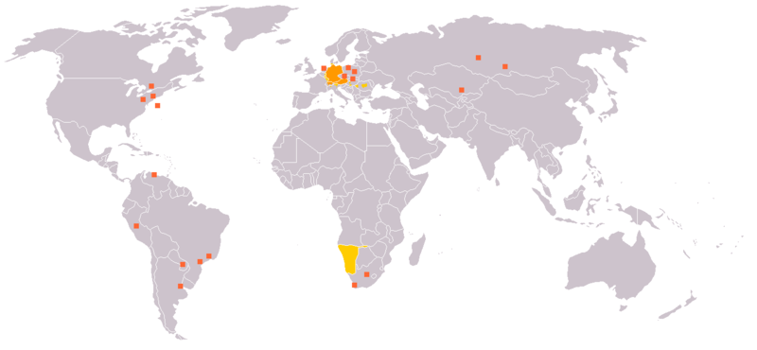

Demographics of Germany
Germany’s population is approximately 82,220,000, making it the 14th most populated country in the world, and it remains the second most populated country in the European Union. Germany is also broadly considered a middle class society whose social welfare system provides universal health care, unemployment compensation, and other social needs. In addition, Germany is said to have one of the world's highest levels of education, technological development, and economic productivity.
In 2005 Germany had 82 cities with a population of more than 100,000 people. Germany's population is characterized by zero or declining growth. Despite its large population, it has one of the lowest fertility rates in the world, with only 1.41 children per mother rating.
More than 16 million people are of non-German descent (first and second generation, including mixed heritage), about seven million of which are foreign residents. The largest ethnic group of non-German origin are the Turkish (about 2.3 million) while the rest are from European states such as Serbia, Greece, Italy, Poland and Croatia. Germany now has Europe's third-largest Jewish population. There are also around 100,000 Afro-Germans, as well as, nearly 50,000 Indian-Germans.
Religious practices include Protestant (Lutheran, Reformed, Mennonite, Amish, and others),
Roman Catholic, Jewish, and others. Roman Catholic is mainly practiced in the South East (Southern Bavaria) and the Far West (Rheinland & Cologne). Most Protestants are located in Northern states. Muslim, Orthodox, and Jewish minority communities are mainly in the big cities.
German is Germany's only official and most-widely spoken language. Standard German is understood throughout the country. Danish, Low German, the Sorbian languages (Lower Sorbian and Upper Sorbian), and the two Frisian languages, Saterfrisian and North Frisian, are officially recognized and protected as minority languages by the European Charter for Regional or Minority Languages in their respective regions.
German dialects are used in everyday speech especially in rural regions. The status of different German dialects can be very different. The Alemannic and Bavarian dialects of the south are respected by speakers and are used in most social situations. The Saxonian and Thuringian dialects have less prestige and therefore their use is less approved. Middle German dialects tend to be only pronunciation variants of Standard German.
English is the most common foreign language in Germany. According to a 2004 survey, two-thirds of Germany's citizens have at least some basic knowledge of English. About 20% of German’s speak French, followed by Russian (7%), Italian (6.1%), and Spanish (5.6%).
Taken from:http://www.germany.com/about-germany/demographics.php http://en.wikipedia.org/wiki/Demographics_of_Germany

Population in the US
The population of German Americans is approximately 50,764,352 forming the largest self-reported ancestry group in the United States, outnumbering the Irish and English. In 2006, they made up 17.1% of the U.S. population. California and Texas have the largest populations of German origin, although upper Midwestern states, including North Dakota and Wisconsin, have the highest proportion of German-American population.
10 FACTS ABOUT DEMOGRAPHICS IN GERMANY
01. Germany has the world's 14th largest population, but by 2050, it is expected to have only the world's 26th largest.
02. Around 165,000 Germans moved abroad in 2007. Favorite destinations included Switzerland (20,000 people), the United States (14,000), Poland (10,000), and Austria (10,000).
03. The average age of German women having their first child (29 years old) is the highest in Europe.
04. By next year, 2009, an estimated 390,000 empty residences will have been torn down in eastern Germany since 1990.
05. With current birthrates and without immigration, Germany's population would drop to 24 million people by 2100.
06. An estimated 37 percent of the German population will be 60 and older by 2050.
07. The largest numbers of foreign citizens living in Germany come from Turkey (1.7 million), Italy (528,000), and Poland (384,000).
08. An average of 120,000 people per year become naturalized German citizens. The biggest countries of former citizenships are Turkey, Serbia, and Poland. Around 800,000 people of Turkish origin are German citizens.
09. Around 96 percent of Germany's over 15 million people with a "migration background" - immigrants and their descendants - live in the former West Germany or Berlin. They make up around 40 percent of the populations of the western cities of Stuttgart and Frankfurt.
10. Germany's annual average ratio of 8 births per 1,000 inhabitants is the world's lowest. The world's highest ratios are in Mali and Niger, both with over 49 births per 1,000 people.

Takenfrom:http://knowledge.allianz.com/en/globalissues/demographic_change/country_profiles/germany_demographic_profile_factsheet.html

Phonology

German Vowels
- Short [i y u e ø o] occur only in unstressed syllables of words that are foreign that have been assimilated into the German language.
- The schwa [ə] occurs only in unstressed syllables. It is frequently considered a complementary allophone together with [ɛ] which cannot take place in unstressed syllables. If a sonorant follows in the syllable coda, the schwa often disappears so that the sonorant becomes syllabic. Before /r/, this is realized as [ɐ] in many varieties.
- The long open-mid front unrounded vowel [ɛ:] is combined with the close-mid front unrounded vowel [e:] in many varieties of standard German.
Taken from:
http://en.wikipedia.org/wiki/German_phonology
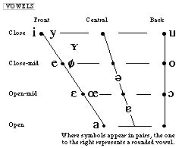
(taken from http://classweb.gmu.edu/accent/nl-ipa/germanipa.html)
To hear pronunciations of the German vowels, visit:
http://www.andrewbrotherton.com/languages/ipa/vowel_files/ipa_vowel_soundchart_german.htm

German Consonants
With approximately 25 phonemes, the German consonant system displays an average number of consonants when compared to other languages such as English.
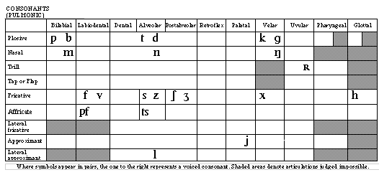
(taken from http://classweb.gmu.edu/accent/nl-ipa/germanipa.html)

- 1. In the northern varieties, [ʔ] occurs before word stems with an initial vowel. It is not considered a phoneme, but an optional boundary mark of word stems; therefore it is not shown on the graph.
- 2. [d͡ʒ] and [ʒ] occur only in words of foreign origin. In certain varieties, they are replaced by [t͡ʃ] and [ʃ] altogether.
- 3. [ʋ] is occasionally considered to be an allophone of [v], especially in Southern varieties of German.
- 4. [ç] and [x] are traditionally regarded as allophones after front vowels and back vowels. According to some analysis, [χ] is an allophone of [x] after /a a:/ and according to some also after /ʊ ɔ a͡ʊ/.
- 5. [r], [ʁ] and [ʀ] are in free variation with one another. [r] is utilized mainly in Southern varieties. In the syllable coda, the allophone [ɐ] is used in many varieties, except in the South-West.
- 6. Some phonologists deny the phoneme /ŋ/ and use /nɡ/ instead, and /nk/ instead of /ŋk/. The phoneme sequence /nɡ/ is realized as [ŋɡ] when /ɡ/ can start a valid onset of the next syllable whose nucleus is a vowel other than unstressed /ə/, /ɪ/, or /ʊ/. It becomes [ŋ] otherwise.
- 7. The voiceless stops /p/, /t/, /k/ are aspirated except when preceded by a sibilant. The obstruents /b d ɡ z ʒ/ are voiceless [b̥ d̥ ɡ̊ z̥ ʒ̊] in the Southern varieties.
The term ich-Laut refers to the voiceless palatal fricative [ç], the term ach-Laut to the voiceless velar fricative [x]. In German, these two sounds are allophones occurring in complementary distribution. The allophone [x] occurs after back vowels, the allophone [ç] after front vowels and consonants.
The term umlaut refers to a marking over the vowels a, o, and u to signal a change in the sound and meaning of a word.
(Taken from http://en.wikipedia.org/wiki/German_phonology)

Syllable Stress
Stress in German usually falls on the first syllable, with a few exceptions:
- Many words with a foreign orgin, especially proper names, keep their original stress.
- Verbs of the "-ieren" group ("studieren", "kapitulieren", "stolzieren", etc.) receive stress on the second to last syllable.
- Compound adverbs, with her, hin, da, or wo as their first syllable, receive the stress on the second syllable.
(Taken from http://en.wikipedia.org/wiki/German_phonology)

Syntax

Declaratives
German word order is similar to English. This is true for simple subject + verb (conjugated or infinite) + object sentences. With compound verbs, the second part of the verb phrase (past participle, separable prefix, infinitive) goes last, but the conjugated element is still second. However, German often prefers to begin a sentence with something other than the subject. No matter which element begins a German declarative sentence (a statement), the verb is always the second element. The subject will either come first or immediately after the verb if the subject is not the first element. An exception to this rule: interjections, exclamations, names, certain adverbial phrases - usually set off by a comma.
Taken from:
http://german.about.com/library/weekly/aa032700b.htm

Questions
a) when asking for certain information:
question word + verb + subject + predicate
b) when asking yes/no questions:
verb + subject + predicate

Negation
- with nicht
follows verbs | precedes prepositional phrases
precedes adjectives | precedes nouns with a definite article
precedes adverbs | precedes a possessive
- with kein
precedes nouns with an indefinite article
precedes nouns with no article

Time, Manner, Place
- In the expression of time, manner, and place, German syntax varies from English. German order is as follows: Time, Manner, Place.
Taken from:
http://german.about.com/library/weekly/aa032700b.htm
http://www.lerc.educ.ubc.ca/LERC/courses/489/worldlang/german/frame_1.htm

Morphology

Nouns
- In German, ALL nouns are capitalized, regardless of type or sentence position.

Pronouns
- The German pronoun for "I" is not capitalized.
However, the German pronoun for the formal "you" (Sie) is capitalized.
- The gender of the relative pronoun is determined by the gender of the word to which it is refering and its case is determined by its function in the relative clause.
- Reflexive pronouns are most frequently used with reflexive verbs in either the accusative or dative case, depending upon the meaning of the verb.

Plural Forms
- German nouns can be pluralized in many ways, some words are done by umualating the vowel or you may add the following: -no, -e, -er, -en/-n/-nen, -s

Verbs
- In German there are six modal verbs, which are commonly used and can be conjugated in relation to the infinitive, past tense, and future. They also share a common pattern of conjugation. The modal verbs are almost always used with another verb, which is required to complete the meaning. Ex: fein (be) war (was) gemefen (been)
- German never uses a form of do as an auxiliary. Forms of do are used only for the main verb.
- Many German verbs have a prefix in their infinitive form, which separates from the verb in certain sentences and will appear at the end of the phrase. In a dependent clause the whole verb will appear at the end. For a list of separable prefix verbs go to: http://web.wm.edu/modlang/gasmit/grammar/presverb/sepprefx.htm

Prepositions
- German prepositions may be classified according to the case of their object. A few may take accusative objects, dative objects, some accusative or dative objects, and genitive objects. For more information when to use accusative, dative, or genitive prepositions go to:
  - http://web.wm.edu/modlang/gasmit/grammar/nouns/accfunc.htm
  - http://web.wm.edu/modlang/gasmit/grammar/nouns/datfunc.htm
  - http://web.wm.edu/modlang/gasmit/grammar/nouns/genfunc.htm

Gender
There are three gender forms in German: masculine, feminine, and neuter.
Der, die, das = definite article “the”
Mein, meine, mein = indefinite article “a, an”

 | Masculine | Feminine | Neuter
People | der | die | das
Objects | der | die | das
Possessives | mein | meine | mein
Adjectives | mein | meine | mein

Taken from:
http://web.wm.edu/modlang/gasmit/grammar/?svr=www
http://www.germanlanguageguide.com/german/grammar/auxiliary-verb.asp
http://www.lerc.educ.ubc.ca/LERC/courses/489/worldlang/german/frame_1.htm
Greenfield, E.V. (1964). An Outline of German Grammar. New York: Barnes and Nobles.

26 Common English Pronunciation Errors made by German Speakers
Information taken from http://www.btinternet.com/~ted.power/l1german.html

FIX PROBLEM | ENGLISH SOUND | - | COMMON ERROR | -
Tip of tongue behind top teeth. | /d/ | "made" | /t/ | "mate"
Tongue low & back. Jaws together. Long. | /ɔ:/ | "nought" | /ɒ/ | "not"
Fix tongue in central position. Long. | /ɜ:/ | "bird"
Weak endings: e.g. "London" "England" | /ə/ | "the" (schwa)
Tongue moves from front centre to front high. | /eɪ/ | "late" | /e/ | "let"
From low front vowel to lips tightly rounded. | /aʊ/ | "cow"
Tongue central. Then tightly round lips. | /əʊ/ | "bone" | /ɔ:/ | "born"
Voiced. Vibration. Trap air with lips. | /b/ | "bill" | /p/ | "pill"
Voiced. Friction with top teeth & bottom lip. | /v/ | "of" | /f/ | "off"
Voiced. Friction with top teeth & bottom lip. | /v/ | "vet" | /w/ | "wet"
Voiceless. Friction. Tongue between teeth. | /θ/ | "thin" | /d/ | "din"
Voiceless. Friction. Tongue between teeth. | /θ/ | "thin" | /s/ | "sin"
Move tongue to a lower front position. | /æ/ | "man" | /e/ | "men"
Voiced. Friction. Tongue between teeth. | /ð/ | "clothe" | /z/ | "close" /z/
Start with lips tightly rounded. Unround & glide. | /w/ | "west" | /v/ | "vest"
Voiced: tip of tongue behind top teeth. Friction. | /z/ | "rise" | /s/ | "rice"
Voiceless. Friction. Front of tongue to palate. | /ʃ/ | "sherry" | /ʧ/ | "cherry"
Voiced: Front of tongue to palate. Friction. | /ʒ/ | "confusion" | /ʃ/ | "Confucian"
Unvoiced: Tip to alveolar. Front to palate. | /ʧ/ | "cherry" | /ʃ/ | "sherry"
Unvoiced: Tip to alveolar. Front to palate. | /ʧ/ | "chin" | /ʤ/ | "gin"
Voiced: Tip to alveolar. Front to palate. | /ʤ/ | "Jerry" | /ʃ/ | "sherry"
Voiced: Tip to alveolar. Front to palate. | /ʤ/ | "job" | /j/ | "yob"
Voiced stop: back of tongue to back roof. | /ŋ/ + /g/ | "thing" | /ŋ/ + /k/ | "think"
Back of tongue to back roof. Nasal. | /ŋ/ + /k/ | "think" | /ŋ/ + /g/ | "thin" + k or g
British "r" is weaker & usually silent  unless followed by a vowel. | silent | "survivor" | /r/ | "Sir Ivor"
Glide /j/(i:) the tongue quickly to next sound | /j/ | "yam" | /ʤ/ | "jam"
Voiced. Friction. Tongue between teeth. | /ð/ | "they" | /d/ | "day"

Common Errors made in English by German Speakers
Information taken from http://esl.fis.edu/grammar/langdiff/german.htm

Alphabet: The German alphabet contains the same 26 letters as the English alphabet, plus the umlauted letters: ä, ö, ü, and the ß (scharfes S or double-s). German ESL students may have interference problems in class when the teacher spells out words. For example, beginners commonly write i or a when the teacher says e or r.
Phonology: The sounds of English and German are similar, as are stress and intonation patterns. However, the /th/ sound as in words like the, and thing does not exist in German, and many speakers have problems producing such words correctly. German words beginning with a /w/ are pronounced with a /v/. This explains the mispronunciation of English words we or wine as ve and vine.
Grammar - Verb/Tense: There is a significant lack of correspondence between the tenses used in English to convey a particular meaning and those used in German. For example, German does not have a continuous tense form, so it is common to hear sentences such as I can't come now; I eat my dinner; or conversely He is riding his bike to school every day.
Another example of the lack of correspondence is the use of the present simple in German where English uses the future with will. This leads to mistakes such as: I tell him when I see him.
A further common problem for Germans is choosing the correct tense to talk about the past. Typically spoken German uses the present perfect to talk about past events: Dann habe ich ein Bier getrunken. The same tense is used in English produces the incorrect: Then I have drunk a beer.
Grammar - Other: German is an inflected language. This means that most of the parts of speech change according their function in the sentence. This causes many more difficulties for English native-speakers learning German than for Germans learning English, which is largely uninflected.
German has three features of word order than do not exist in English: Firstly, the main verb must be the second element in the independent clause. This often requires an inversion of subject and verb. For example: Manchmal komme ich mit dem Bus in die Schule. (Sometimes I come to school by bus.) Secondly, the past participle must always be the last element in the independent clause. Example: Ich habe ihn night gesehen. (I have not seen him.). Thirdly, the main verb must be the last element in the dependent clause. For example: Sie fragte mich, weil ich zuviel Bier getrunken habe. (I feel bad because I have drunk too much beer.)
Vocabulary: German and English share many cognates: Winter/winter, Haus/house, trinken/drink, etc. Many cognates, however, do not have the same meaning (i.e. they are false friends). For example, the German word also means so in English, not also; aktuell means current not actual.
Miscellaneous: German has stricter punctuation rules than English. This can result in the unnecessary punctuation of sentences such as: He said, that he was tired. Nouns in German are capitalized, which often leads to students writing English nouns with capital letters.

Tests & Assessment Materials
Sparse information is available on standardized tests and assessments in German. For further information contact the German Association of Academic Speech-Language Therapists at info@dbs-ev.de.
(Information taken from http://www.dbs-ev.de/english.htm)

Pragmatics
Things to remember when interacting in a formal or clinic setting:

- Germans tend to be private; therefore you may want to give notice before calling a client’s home.
- Titles are very important.
  - Always be sure to address people by their full title.
- Germans are strongly individualistic.
- Punctuality is valued and expected. Deadlines are expected to be honored.
- Shake hands at both the beginning and the end of a meeting. If a nod or slight bow is given, it is considered rude to not reciprocate. Eye contact is also important.
- When being introduced to a woman, it is polite to wait to see if she extends her hand first.
- Business is viewed as being very serious. Humor is usually not appreciated.
- Age takes precedence over youth.
- Germans tend to have a larger personal space.

Taken from:
http://www.cyborlink.com/besite/germany.htm

History of Germany

World War II
For Germans, the Third Reich is a dark part of their history, but they are committed not to allow history to repeat itself. Like in most European countries, Nazi signs and rhetoric are a crime.
The Third Reich was the time of national socialist rule in Germany (between 1933 and 1945). Adolph Hitler was appointed as the leader of the National Socialist German Workers’ Party shortly after a failed attempt to control the government. Although the Nazis did not have the majority within the German government nor did they have the majority of the German vote, within months they established a dictatorship that forbade opposing political parties. They successfully suppressed, by means of instilling terror in their opponents, criticism about the government.
Even though the Nazis persecuted the Jews from the beginning, it was in 1935 when the Nuremberg Laws were established, depriving Jews of their civil rights. By 1941 their systematic extermination had started. The Nazis were responsible for the Holocaust, the killing of approximately six million Jews as well as two million ethnic Poles and four million others who were deemed unworthy (disabled and mentally ill, Soviet POWs, homosexuals, Freemasons, Jehovah's Witnesses, and the Roma) as part of a program of deliberate extermination.
In 1939 Hitler invaded Poland and the allies declared war on Germany. It was the beginning of WWII. By 1945 the Third Reich collapsed, German troops surrendered and Hitler committed suicide.

The above information is from German Culture and Society (Briel, H., 2002)
After the end of WWII, Germany was divided into two distinct and separate states: the Federal Republic of Germany and The German Democratic Republic. The former was protected by England, United States, and France, whereas the latter was under the protection of the Soviet Union. To this end, the Berlin Wall was erected in 1961 and was not demolished until 1989.
The above information is from Contemporary German Cultural Studies (Phipps, A., 2002)
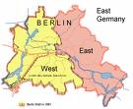

The above images are from: http://images.google.com/images?gbv=2&hl=en&sa=1&q=berlin+wall&aq=f&oq=

Culture of Germany

Society and Culture
In Germany, adherence to plans, routines, and schedules are highly emphasized and expected. Following a carefully prepared schedule, both professionally and personal activities, provides the German people with a sense of security.

Germans view rules and regulations as tools that allow people to have expectations about their lives, thus they plan their lives around those expectations.
Unlike in the US, the idea of finding the next, improved way to perform a job is not as highly valued. If a way of performing a task is satisfactory, they do not see the need to find a new way to complete the same task.
Their lifestyle could be seen as very regimented, all activities have a set time to start and end. There is a proper time for every activity. When work hours end, Germans are expected to leave the office. Otherwise it is viewed as poor planning on their part.

Germans take great pride in their homes. They are kept neat and tidy at all times, with everything in its appointed place.
As a whole, Germans prefer to keep their personal lives separate from their professional lives. Their homes are the places where they can show their individualism and simply relax. Because of this, Germans only invite close friends and relatives to their homes.

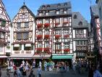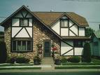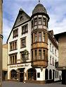

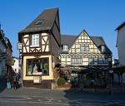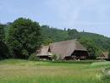

The above images are from: http://images.google.com/images?gbv=2&hl=en&q=german+house&sa=N&start=18&ndsp=18

Food and Drinks
Throughout Germany common dishes include pork, sausages, Sauerkraut, and potatoes. But some dishes are specific to each region as well. In the north, fish dishes are ever present. In the mountainous areas wild boar, rabbit, and deer are a delicacy. White sausage is a famous dish from Bavaria. Homemade pasta and soup with egg are specialty dishes from Schwaben.

Some dishes are designated for special occasions. On Christmas, the roast is made from goose; New Year’s Eve meal has carp, and for Easter, the main dish is lamb.

German cuisine is also famous for its variety of breads; they have over 3000 different types of breads. Brötchen (rolls) are part of the standard breakfast and Pumpernickel is used for in-between snacks and supper.

German beer is famous worldwide; there are over 1400 breweries in Germany. These adhere to the law on beer purity, containing only malt, hops, yeast, and water.

The above information is from German Culture and Society (Briel, H., 2002)
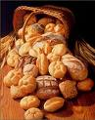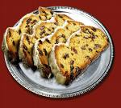

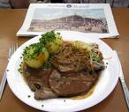

Speech-Language Pathologists and Audiologists
For more information or additional SLPs and AuDs please visit http://www.asha.org/proserv/.

Speech-Language Pathologists
James, Diana MA,MS,EDD
7306 Woodmont
Amarillo, TX 79119
806-236-4995, 806-353-6787
Email: dpj526@sbcglobal.net
Facility Type: School
Payment Type: Health Insurance
Krause, Suzanne BA, MA
305 S Broadway Ave
Suite 502
Tyler, TX 75702
903-531-2581
Email: tylerspeech@tylerspeech.com
Facility Type: SLP or AUD Office
Payment Type: Medicaid,Private Health Insurance

Audiologists
Navarro, Richard Ph.D.
2622 Fondren Rd.
Houston, TX 77063
713 978 6302
Email: taureadordoc@aol.com
Director:
Facility Type: SLP or AUD Office
Payment Type: Medicare ,Private Health Insurance ,Credit Card

Lakeview Hearing Center
304-B Gateway Loop
Marble Falls, TX 78654
830 693-1251
Email:
Director: Angela Wooten
Facility Type: Speech/Hearing Cntr or clinic
Payment Type: Medicare ,Medicaid ,Private Health Insurance ,Credit Card

Singleton, James M.S.P.A.
Beltone Audiology Center
910 N Main
Mcallen, TX 78501
(956) 686-6881
Email:
Facility Type: SLP or AUD Office
Payment Type: Medicaid,Private Health Insurance ,Credit Card

Web Resources

German Cuisine

Website Name: German Culture
Web Address: http://www.germanculture.com.ua/library/weekly/german_food.htm

Website Name: All Recipes
Web Address: http://allrecipes.com/HowTo/German-Cuisine/Detail.aspx

Website Name: Sally’s Place
Web Address: http://www.sallybernstein.com/food/cuisines/germany.htm

The Truth About Germany: German Cuisine
Video: http://www.dailymotion.com/video/x9410j_euromaxx-the-truth-about-germany-ge_people

German Language

Website Name: Text to Speech
Web Address: http://text-to-speech.imtranslator.net/speech.asp

Website Name: English Grammar Online 4U
Web Address: http://www.ego4u.com/en/dictionary

Website Name: Speak German
Web Address: http://www.speakgerman.co.uk/phrases/

German History

Website Name: German Culture
Web Address: http://www.germanculture.com.ua/library/history/bl_german_history.htm

Website Name: Info Please
Web Address: http://www.infoplease.com/ipa/A0107568.html

Website Name: Timeline of German history
Web Address: http://en.wikipedia.org/wiki/Timeline_of_German_history

German Traditions

Website Name: German Originality
Web Address: http://germanoriginality.com/heritage/tradition.php

Website Name: Holiday Traditions
Web Address: http://www.californiamall.com/holidaytraditions/traditions-germany.htm
Website Name: German Traditions and Customs
Web Address: http://www.germanculture.com.ua/library/links/traditions.htm

Therapy Materials
The Picture Master products can be found at the Academic Communication Associates, Inc. – Speech, Language, and Learning Resources for Children and Adults website, http://www.acadcom.com/Scripts/default.asp; and the Super Duper photo cards can be found at the Super Duper Publications website, http://www.superduperinc.com/.
- Picture Master Board Designer includes images that allow you to design and print picture cards, communication boards and overlays, activity worksheets, and games. Text in English, Spanish, French, and German can be included with the picture.

- Picture Master Language Software includes the Picture Master Board Designer in addition to animation of approximately 3,600 pictures with real speech producing the word (e.g., the act of drinking is shown while the word “drink” is produced). The real speech is available in English, French, Spanish, and German.

- Super Duper Publications provides several photo cards with several languages (English, Spanish, French, German, Japanese, and Chinese) printed on the back.

Research Articles
The following articles may be useful clinical resources about the German language.
Aichert, I., & Kiermeier, S. (2005). New directions in the diagnosis of aphasia in german: LeMo -- a model-based assessment [german]. Forum Logopadie, 19(4), 12-19.
Clausen-Söhngen, M. (2005). Counseling in speech therapy: Counseling in treatment -- treatment in counseling [german]. Forum Logopadie, 19(2), 24-27.
Dehn-Hindenberg, A. (2007). Patients' needs in speech-language pathology: Quality of communication determines therapeutic success [german]. Forum Logopadie, 21(4), 26-32.
Dworzynski, K., Howell, P., Au-Yeung, J., & Rommel, D. (2004). Stuttering on function and content words across age groups of german speakers who stutter. Journal of Multilingual Communication Disorders, 2(2), 81-101.
Fox, A. V., & Dodd, B. (2001). Phonologically disordered german-speaking children. American Journal of Speech-Language Pathology, 10(3), 291-307.
Fuchs, S., Brunner, J., & Busler, A. (2007). Temporal and spatial aspects concerning the realizations of the voicing contrast in german alveolar and postalveolar fricatives... 4th international electropalatography (EPG) symposium, held in edinburgh in september 2005. Advances in Speech Language Pathology, 9(1), 90-100.
Funk, J., Montanus, S., & Kröger, B. (2006). Therapy for neurogenic and developmental speech disorders with the PC-programme "speech trainer" [german]. Forum Logopadie, 20(2), 6-12.
Hild, U. (2008). The cycles remediation approach -- phonological therapy for young children [german]. Forum Logopadie, 22(1), 22-27.
Lleó, C. (2006). The acquisition of prosodic word structures in spanish by monolingual and spanish-german bilingual children. Language & Speech, 49, 205-229.
Macha-Krau, H. (2004). Theory and practice of science in speech therapy [german]. Forum Logopadie, 18(6), 28-31.
Nebel, A., Volkmann, J., & Deuschl, G. (2007). Effects of deep brain stimulation on speech in parkinson's disease -- perceptive profiles, acoustic measures, consequences for voice treatment [german]. Forum Logopadie, 21(6), 32-37.
von Gudenberg, A. (2006). Kassel stuttering therapy: Evaluation of a computer aided therapy [german]. Forum Logopadie, 20(3), 6-11.

Case History For Bilingual Speakers
- Which language(s) was the child surrounded by during the first years of her/his life?

_______________________________________________________________________

- To how many languages, besides English, is your child currently exposed ?
please list these languages

- How many words does your child uses in each of these languages:
__________________________________
__________________________________
__________________________________
__________________________________
__________________________________

- How many words does your child understands in these languages:
__________________________________
__________________________________
__________________________________
__________________________________
__________________________________

- Please list the environments in which these languages are spoken
  - home: mom dad how often______________
  - school: teachers friends how often______________
  - extended family: who ______ how often______________
  - social club:________________how often______________

- To speakers of these languages (spoken by your child), does your child sounds as other children his/her age? yes no
If no, explain__________________________________________________________________
______________________________________________________________________________________________________________________________________________________________________________________________________________________________________________________________________________________________________________________________________________________________________________________________________

- Circle any (as many as you recognize) behaviors exhibited by your child
  - mixes words from different languages when speaking
  - uses intonation from one language while speaking another
  - forms sentences in the wrong order (ie. nouns before adjectives-“car green”)
  - fails to use or inconsistent use of tense markers
  - fails to use or inconsistent use of third person “s” (walks)

References
(2009). German Phonology. Retrieved May 28, 2009, from Wikipedia Web site: http://en.wikipedia.org/wiki/German_phonology
(2007). Demography of germany. Retrieved May 28, 2009, from Germany.com Web site: http://www.germany.com/about-germany/demographics.php
(2009, May 18). Demographics of germany. Retrieved May 25, 2009, from Wikipedia Web site:
http://en.wikipedia.org/wiki/Demographics_of_Germany

Wish, V. (2008, July 21). Germany demographic profile part 2: fact sheet. Retrieved June 2, 2009, from Allianz Web site: http://knowledge.allianz.com/en/globalissues/demogra phic_change/country_profiles/germany_demographic_profile_factsheet.html
Maddieson, I. German ipa. Retrieved May 31, 2009, Web site: http://classweb.gmu.edu/accent/nl- ipa/germanipa.html
German vowels. Retrieved May 31, 2009, from German IPA Vowels Web site:
http://www.andrewbrotherton.com/languages/ipa/vowel_files/ipa_vowel_soundchart_german.htm

(2009). Word order in german. Retrieved May 27, 2009, from About.com Web site:
http://german.about.com/library/weekly/aa032700b.htm

(2004). German. Retrieved May 28, 2009, from World language fair for educators Web site:
http://www.lerc.educ.ubc.ca/LERC/courses/489/worldlang/german/frame_1.htm

Smith, G. (1997). Grammar of german. Retrieved May 25, 2009, from German grammar Web
site: http://web.wm.edu/modlang/gasmit/grammar/?svr=www

(2009). German grammar: Auxiliary verb. Retrieved May 30, 2009, from German language
guide.com Web site: http://www.germanlanguageguide.com/german/grammar/auxiliary-verb.asp

Greenfield, E.V. (1964). An Outline of German Grammar. New York: Barnes and Nobles.
Priest, M. Germany. Retrieved May 31, 2009, from Cyborlink.com Web site: http://www.cyborlink.com/besite/germany.htm
Briel, H. (2002). German Culture and Society. New York, NY: Oxford University Press.

Europa: Getaway to the European Union (2009). Retrieved May 25, 2009 from
http://europa.eu/index_en.htm

Kwintessential (2009). Germany - Language, Culture, Customs and Business Etiquette.
Retrieved May 25, 2009, from http://www.kwintessential.co.uk/resources/global-etiquette/germany-country-profile.html

Phipps, A. (Ed.). (2002). Contemporary German Cultural Studies. New York, NY: Oxford
University Press.

Photius (1996). The 50 Most Widely Spoken Languages. Retrieved May 25, 2009, from
http://www.photius.com/rankings/languages2.html

US Census (2000). Retrieved may 30, 2009, from http://www.census.gov/prod/2003pubs/c2kbr-
29.pdf

Wikipedia (2009). Retrieved May 25, 2009 from http://en.wikipedia.org/wiki/High_German.

